

**Applecross SHS**

**Year 11 Chemistry 2017**

**Comprehension Extended Response Assessment**

**Ocean Acidification**

Instructions:

* Read the following articles on ocean acidification and prepare for a validation test in class based on this information
* You will be allowed to bring in these articles to the validation test but please do not write on these pages – highlighting key points is allowed
* Key areas are as follows;
  + What is ocean acidification?
  + What causes it?
  + What are its effects?
  + What chemistry is involved?
  + What can be done to address the problem?
* Note that some questions on the test will not be directly answered by these articles and will require interpretation
* It is suggested that you make your own summary of these articles to learn the material but you will not be able to bring in your summary to the test
* Learn as much as you can, you may like to do some further research
* Good Luck

**Ocean acidification and its effects** 27 April 2017

Article extract from https://coastadapt.com.au/ocean-acidification-and-its-effects

Oceans absorb a substantial proportion of the CO2 emitted into the atmosphere by human activities, with potentially negative effects on shell-forming organisms

Oceans absorb a substantial proportion of the CO2 emitted into the atmosphere by human activities, with potentially negative effects on shell-forming organisms.

* Increasing CO2 in the atmosphere due to human activities not only affects the climate; it also has direct, chemical effects on ocean waters.
* The oceans have absorbed between a third and a half of the CO2 humans have released into the atmosphere since about 1850.  This has slowed the rate of climate change.
* When CO2 dissolves in seawater, the water becomes more acidic. The acidity of the oceans has increased by 26 % since about 1850, a rate of change roughly 10 times faster than any time in the last 55 million years.
* Associated chemical reactions can make it difficult for marine calcifying organisms, such as coral and some plankton, to form shells and skeletons, and existing shells become vulnerable to dissolution.
* The extent to which calcifying organisms are already being affected by acidification is unclear, as this is a very new area of study.  Limited evidence suggests that some organisms are more sensitive than others.
* The rate at which acidification occurs is a determining factor in the extent to which calcifying organisms will be able to adapt.
* The impacts of acidification will extend up the food chain to affect economic activities such as fisheries, aquaculture and tourism. Wherever there are marine calcifying organisms, there are risks from ocean acidification.

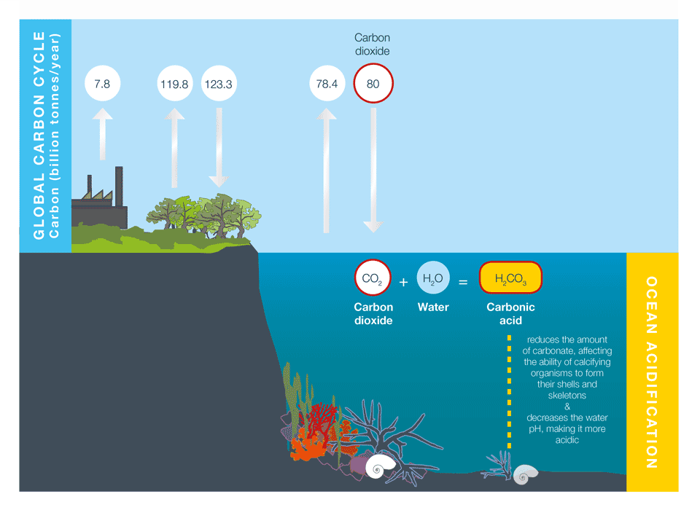

**Figure 1:** Some of the carbon dioxide emitted to the atmosphere by human activities is absorbed by the oceans. When carbon dioxide combines with water in the ocean it forms carbonic acid, which makes the ocean more acidic and may reduce the ability of calcifying organisms to form their shells and skeletons. Source: Adapted from J. Cook, skepticalscience.com.

**What is ocean acidification?**

Human activities release CO2 into the atmosphere, which leads to atmospheric warming and climate change, as explained in [*Causes of climate change*](https://coastadapt.com.au/causes-of-climate-change-and-sea-level-rise). Around a third to a half of the CO2 released by human activities is absorbed into the oceans. While this helps to reduce the rate of atmospheric warming and climate change, it also has a direct, chemical effect on seawater, which we call *ocean acidification* (Figure 1).

**What is pH?**

Ocean acidification is often expressed in terms of the pH of seawater.  pH is a measure of acidity or alkalinity. A pH below 7 is considered acidic, and a pH greater than 7 is considered alkaline, or basic.

Average ocean water pH is currently 8.1.  The pH scale is logarithmic, so a one point change on the scale means a tenfold change in concentration.

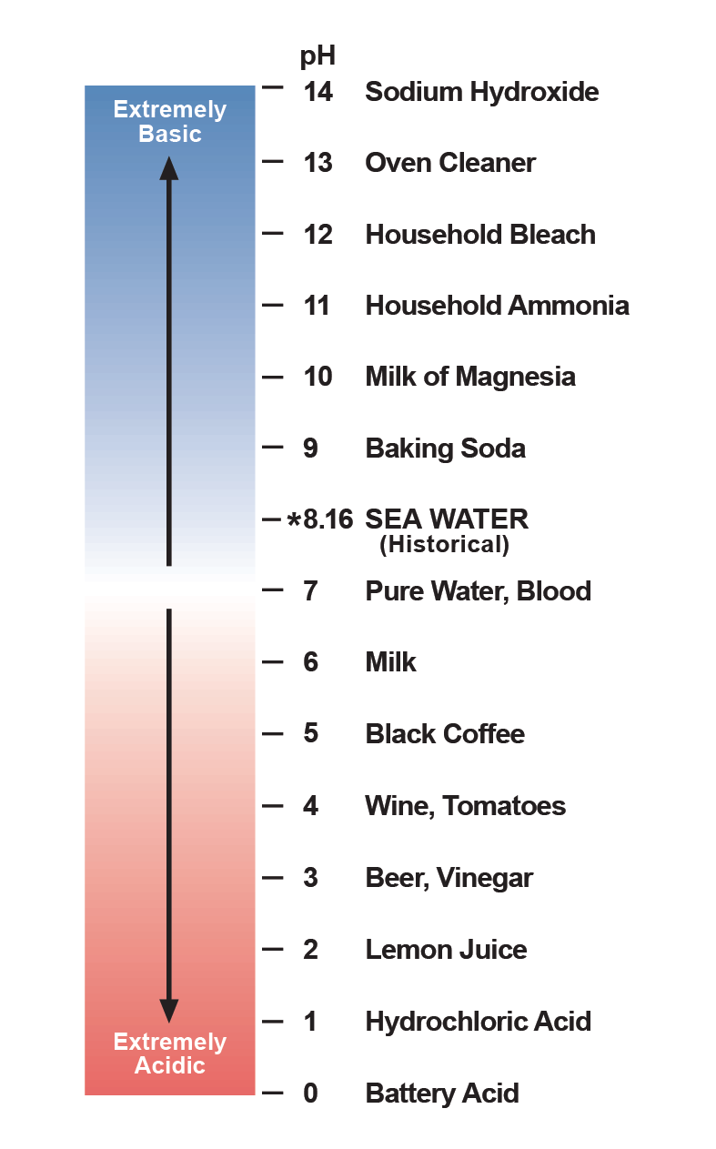

**Figure B1:** The pH scale. Source: Feely et. al 2006.

**What are the observed changes?**

Since around 1850, the oceans have absorbed between a third and a half of the CO2 emitted to the atmosphere. As a result, the average pH of ocean surface waters has fallen by about 0.1 units, from 8.2 to 8.1 (Figure 2). This corresponds to a 26 % increase in ocean acidity, a rate of change roughly 10 times faster than any time in the last 55 million years.

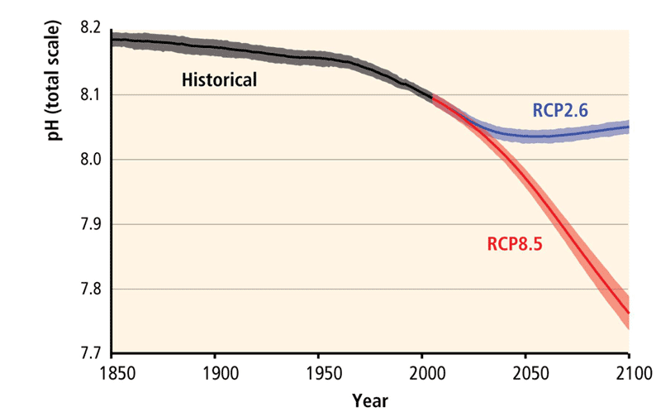

**Figure 2:** Global mean ocean surface pH from 1850 to 2100, from climate models. The modelled historical trend shows an overall decrease of about 0.1 pH units (black). Projections up to 2100 are shown for high emission scenarios (RCP8.5, red) and low emission scenarios (RCP2.6, blue). Source: Gattuso et al. 2014, Fig. OA1b.

**What can we expect in the future?**

The degree of future ocean acidification will be very closely linked to future increases in atmospheric CO2 (Figure 3). If greenhouse gas emissions continue as they are doing at present (the RCP8.5 trajectory, see [*Causes of climate change*](https://coastadapt.com.au/causes-of-climate-change-and-sea-level-rise)*)*, seawater could increase its acidity by 0.4 units by the end of the century.

The acidification of the oceans will not be uniform worldwide. Polar seas, and upwelling regions, often found along the west coasts of continents, are expected to acidify faster than temperate or tropical regions. The pH will vary significantly depending on the ecosystem. In some parts of the Arctic the water is acidic enough to corrode some types of shells and in California occasional corrosive events have already occurred. Most surface waters will be continually corrosive within decades.

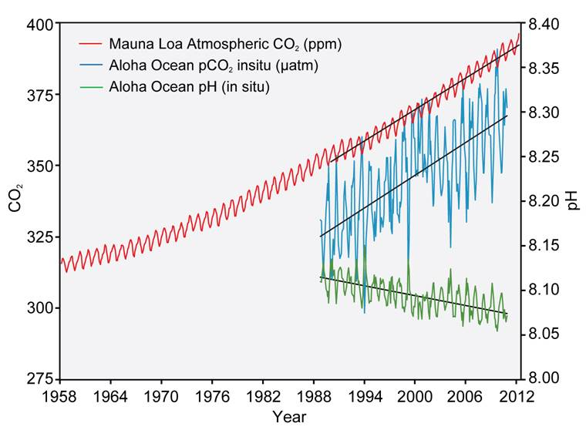

**Figure 3:** Atmospheric CO₂ concentrations and ocean pH values. Atmospheric CO₂, shown in blue (seasonal variations) and red (long-term smoothed trend), is measured at Mauna Loa, Hawai’i. Ocean pH values (green and orange) are from the ocean to the north of Hawa’ii (Station Aloha). As CO₂ accumulates in the ocean, the water becomes more acidic (the pH declines). Source: Modified from Feely et al. 2009.

**What are the effects of ocean acidification on marine organisms and ecosystems?**

Ocean acidification reduces the amount of carbonate, a key building block in seawater. This makes it more difficult for marine organisms, such as coral and some plankton, to form their shells and skeletons, and existing shells may begin to dissolve.

The present-day pH of seawater is highly variable, and a single organism can cope with fluctuations of different pH levels during its lifetime. The problem with ocean acidification is the sustained nature of the change, as the risk comes from the lifetime exposure to lower pH levels. The rapid pace of acidification will influence the extent to which calcifying organisms will be able to adapt.

The impacts of ocean acidification are not uniform across all species. Some algae and seagrass may benefit from higher CO2 concentrations in the ocean, as they may increase their photosynthetic and growth rates. However, a more acidic environment will harm other marine species such as molluscs, corals and some varieties of plankton (Figure 4). The shells and skeletons of these animals may become less dense or strong. In the case of coral reefs this may make them more vulnerable to storm damage and slow the recovery rate.

Marine organisms could also experience changes in growth, development, abundance, and survival in response to ocean acidification (Figure 5). Most species seem to be more vulnerable in their early life stages. Juvenile fish for example, may have trouble locating suitable habitat to live.

Despite the different responses within and between marine groups, positive or negative, research suggests that ocean acidification will be a driver for substantial changes in ocean ecosystems this century. These changes may be made worse by the combined effect with other emerging climate-related hazards, such as the decrease of ocean oxygen levels – a condition known as ocean deoxygenation –that is already affecting marine life in some regions (Long et al. 2016).

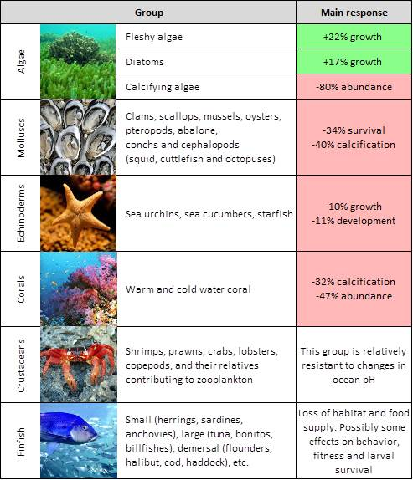

**Figure 5:** Summary of effects of ocean acidification among key taxonomic groups. The main responses are represented in percent changes, which could be either positive (green) or negative (red). Source: Adapted from Kroeker et al. 2013.

**What are the effects on human societies?**

Changes in marine ecosystems will have consequences for human societies, which depend on the goods and services these ecosystems provide. The implications for society could include substantial revenue declines, loss of employment and livelihoods, and other indirect economic costs.

Socioeconomic impacts associated with the decline of the following ecosystem services are expected:

* **Food:** Ocean acidification has the potential to affect food security. Commercially and ecologically important marine species will be impacted, although they may respond in different ways. Molluscs such as oysters and mussels are among the most sensitive groups. By 2100, the global annual costs of mollusc loss from ocean acidification could be over US$100 billion for a business-as-usual (RCP8.5) CO2 emissions pathway.
* **Coastal protection:** Marine ecosystems such as coral reefs protect shorelines from the destructive action of storm surges and cyclones, sheltering the only habitable land for several island nations. This protective function of reefs prevents loss of life, property damage, and erosion, and has been valued at US$9 billion per year.
* **Tourism**:  This industry could be severely affected by the impacts of ocean acidification on marine ecosystems (e.g. coral reefs).  In Australia, the Great Barrier Reef Marine Park attracts about 1.9 million visits each year and generates more than A$5.4 billion to the Australian economy.
* **Carbon storage and climate regulation:** The capacity of the ocean to absorb CO2 decreases as ocean acidification increases. More acidic oceans are less effective in moderating climate change.

**What can coastal decision makers do?**

While reducing global greenhouse gas emissions (mitigation) is the ultimate solution to ocean acidification, undertaking some challenging decisions and actions can help us prepare for the adverse effects of ocean acidification. This is the [*adaptation approach*](https://coastadapt.com.au/overview-of-adaptation).

At the local level, the following policy and management options can help to minimise the adverse effects of other local stressors and, as a result, help marine ecosystems to cope better with changing environmental conditions.

* **Improvements in water quality**: Monitoring and regulating localised sources of acidification from runoff and pollutants such as fertilisers.
* **Development of sustainable fisheries management practices:** Regulating catches to reduce overfishing and creating long-term bycatch[[1]](https://coastadapt.com.au/ocean-acidification-and-its-effects" \l "_ftn1" \o ") reduction plans.
* **Implementation of new technologies:** Different techniques can be applied depending on the industry. For example, in the aquaculture industry, new forecasting systems have been developed to account for seasonal upwellings that bring low pH seawaters to the ocean surface and cause massive shellfish die-offs.
* **Sustainable management of habitats:** Increasing coastal protection, reducing sediment loading and applying marine spatial planning.
* **Establishment and maintenance of Marine Protected Areas:** Protecting highly vulnerable and endangered marine ecosystems.

[[1]](https://coastadapt.com.au/ocean-acidification-and-its-effects" \l "_ftnref1" \o ") Bycatch: a fish or other marine species that is caught unintentionally. **Bycatch** is either of a different species, the wrong sex, or is undersized or juvenile individuals of the target species.

**Further information hide −**

The NOAA Ocean Acidification Program (US) provides useful and up to date information:  <http://oceanacidification.noaa.gov/Home.aspx> (accessed 3 June 2016).

In Australia, scientist from the Australian Institute of Marine Sciences (AIMS) are researching the effects of ocean acidification on coral reef organisms and ecosystems: <http://www.aims.gov.au/research/climate-change/ocean-acidification> (accessed 3 June 2016).

This video developed by the Alliance for Climate Education provides an easy introduction to the topic: <https://www.youtube.com/watch?v=Wo-bHt1bOsw>.

However, if you are looking for more in-depth information, try watching this video developed by the World Bank Group's Open Learning Campus : <https://www.youtube.com/watch?v=E39PMzDBtrU&feature=youtu.be&app=desktop>.

**What is ocean acidification?**

Article extract from https://coastadapt.com.au/ocean-acidification-and-its-effects

Acidification is defined as an increase in the concentration of H+ in a solution or a lowering of a solution's [pH](http://www.ozcoasts.gov.au/indicators/ph_coastal_waterways.jsp). Ocean acidification is therefore the reduction of the pH of the world's oceans.

This can occur when [CO2](http://www.ozcoasts.gov.au/indicators/water_column_partial_pressure.jsp) dissolves in water and there is a reaction between the H2O andCO2 to form carbonic acid (H2CO3).

[CO2] + [H2O] <=> [H2CO3]

This weak acid readily releases a proton (H+) and a negatively charged inorganic carbon ion.

[H2CO3] <=> [H+] + [HCO3-]

The release of the H+ into the water will make it more acidic, that is it will drive the pH down. This increase in H+ will also react with the carbonate ion (CO32-) to form HCO3-

[H+] + [CO32-] <=> [HCO3-]

The overall effect of CO2 dissolving into water is that the concentrations of H+, H2CO3 and HCO3- increase and the concentration of CO32- decreases and the solution is more acidic (i.e. a decrease in pH. The world's oceans readily exchange CO2 with the atmosphere. As the concentration of CO2 in the Earths atmosphere increases, so too does the level of CO2 that the oceans absorb and therefore increasing the concentrations of H+ in the ocean making them more acidic.

**What is causing ocean acidification?**

As [carbon dioxide](http://www.ozcoasts.gov.au/indicators/water_column_partial_pressure.jsp) obeys Henry's Law (which states that the concentration of a dissolved gas in a solution is directly proportional to the [partial pressure](http://www.ozcoasts.gov.au/indicators/water_column_partial_pressure.jsp) of that gas above the solution) an increase in the concentration of CO2 in the atmosphere directly leads to an increase in the amounts of CO2 absorbed by the oceans. Human induced CO2 emissions have increased since the industrial revolution through the burning of fossil fuels, land use practices and concrete production[1]. This increase from around pre-industrial values of 280 parts per million (ppm) to 383ppm today (See [Enhanced Greenhouse Effect](http://www.ozcoasts.gov.au/indicators/greenhouse_effect.jsp)) has resulted in the acidification of the ocean.

The averaged CO2 concentrations measured at Cape Grim Tasmania from
  1975-2005 [2]. Reprinted with Permission from CSIRO and Bureau of Meteorology.

**Figure 1.** The averaged CO2 concentrations measured at Cape Grim Tasmania from 1975-2005 [2]. Reprinted with Permission from CSIRO and Bureau of Meteorology.

The rate of increase is far greater than generally occurs naturally and is predicted to continue to rise well into the future [3]. Approximately 25% of the CO2 from burning fossil fuels and cement production in the past 200 years has already been absorbed by the oceans. This CO2 absorption has already led to a decrease in the [pH](http://www.ozcoasts.gov.au/indicators/ph_coastal_waterways.jsp) of the oceans of about 0.1 units from pre-industrial levels. While this value seems very small, this is mostly an artefact of the way that pH is measured. Put another way this change represents about a 30% increase in the concentration of H+ in seawater. More importantly the H+ concentration, and the rate at which it is rising, are both still increasing [4].

**What is the significance of Ocean Acidification?**

[**Bioavailability**](http://www.ozcoasts.gov.au/glossary/def_a-b.jsp#bioavailability) **of carbonate**

Many marine organisms make shells or supporting plates out of calcium carbonate (CaCO3) in a process called calcification. As water becomes more acidic, the calcification process is inhibited and the growth and/or survival of certain organisms could be affected. As many of these organisms form the primary production of oceans, any change in their life cycle has the potential to impact all marine ecosystems.

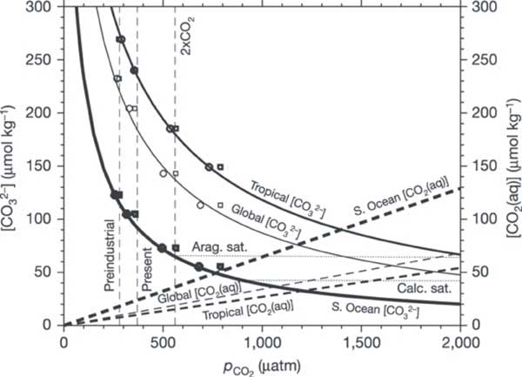

**Figure 2.** Shown are both CO32- concentration (solid lines) and dissolved CO2 concentration (dashed lines) for average surface waters in the tropical ocean (thick lines), the Southern Ocean (thickest lines) and the global ocean (thin lines). Solid and dashed lines were calculated from the thermodynamic equilibrium approach. For comparison, open symbols are for CO32- concentration from a non-equilibrium, model-data approach versus [seawater *p*CO2](http://www.ozcoasts.gov.au/indicators/water_column_partial_pressure.jsp) (open circles) and atmospheric *p*CO2 (open squares); symbol thickness corresponds with line thickness, which indicates the regions for area-weighted averages. The nearly flat, thin dotted lines indicate the CO32- concentration for seawater in equilibrium with aragonite ([aragonite](http://webmineral.com/data/Aragonite.shtml) saturation) and calcite ([calcite](http://webmineral.com/data/Calcite.shtml) saturation). Reprinted by permission from Macmillan Publishers Ltd: Nature, Orr et al. 2005 [5]

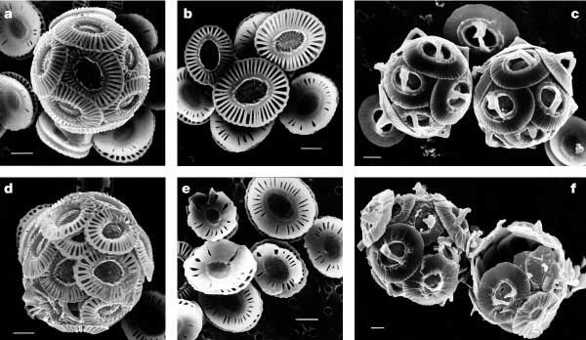

**Figure 3.** The impact of higher than current CO2 concentration on the calcification of coccolithophorids. Shells a, b, d, e, are *Emiliania huxleyi* ; and shells c, f, are *Gephyrocapsa oceanica*. Shells in the top 3 images were grown at slightly above pre-industrial CO2 levels (incubated at [CO2] ≈ 12 µ mol l -1, *p*CO2 levels of 300 ppmv) and those in the bottom 3 images were grown around three times pre-industrial levels (incubated at [CO2] ≈ 30–33 µ mol l -1, *p* CO2 levels of 780–850 ppmv). Scale bars represent 1 µ m. Reprinted by permission from Macmillan Publishers Ltd: Nature, Riebesell et al. 2000 [6]

The Southern Ocean has been identified as being particularly vulnerable to becoming under saturated in calcium carbonate as it already has very low saturation levels [3]. The saturation level of the carbonate minerals is not only dependent on the concentrations of dissolved CO2 and carbonate but also with [water temperature](http://www.ozcoasts.gov.au/indicators/temperature.jsp) and pressure. The solubility of CaCO3 increases with decreasing temperature and increasing depth (See [Carbonate Buffering](http://www.ozcoasts.gov.au/indicators/ocean_acid.jsp#Carbonate_buffering)). However, with increasing dissolved CO2 concentrations the depth at which the CaCO3 minerals will become under saturated will rise, i.e. the depth at which CaCO3 minerals will begin to dissolve (particularly the more soluble mineral form- Aragonite) will become shallower. This saturation depth is predicted to reach the surface in some areas of the Southern Ocean if CO2 levels rise to twice their current levels, which could have a significant impact on the marine food webs on Australia's southern coastline [5].

**References**

1. Antarctic Climate and Ecosystems Cooperative Research Centre (2008). [Position analysis: CO2 and climate change, ocean impacts and adaptation issues](http://www.acecrc.org.au/uploaded/117/797619_20pa02_acidification_0805.pdf). Hobart, TAS.
2. CSIRO Cape Grim Website
3. IPCC (2007). The Fourth assessment report of the Intergovernmental Panel on Climate Change (IPCC). *Climate Change 2007: The Physical Science Basis.* (Solomon, S., D. Qin, M. Manning, Z. Chen, M. Marquis, K.B. Averyt, M. Tignor and H.L. Miller, Editors). Contribution of the Working Group I to the Fourth Assessment Report of the Intergovernmental Panel on Climate Change. Cambridge University Press, 944pp.
4. [The Royal Society](http://www.royalsoc.ac.uk/) (2005) *Ocean Acidification due to increasing atmospheric carbon dioxide.* Science Section, The Royal Society, London.
5. Orr J. C., Fabry V. J., Aumont O., Bopp L., Doney S. C., Feely R. A., Gnanadesikan A., Gruber N., Ishida A., Joss F., Key R. M., Lindsay K., Maier-Reimer E., Matear R., Monfray P., Mouchet A., Najjar R. G., Plattner G. K., Rodgers K. B., Sabine C. L., Sarmiento J. L., Schlitzer R., Slater R. D., Totterdell I. J., Weirig M. F., Yamanaka Y. and Yool A. (2005) *Anthropogenic ocean acidification over the twenty first century and its impact on calcifying organisms* . Nature **437**, 681-686
6. Riebesell, U., Zondervani, I. , Rost, B., Tortell, P.D., Zeebe, R. and Morel, F.M.M. (2000) *Reduced calcification of marine plankton in response to increased atmospheric CO2*. Nature **407**, 364-367.
7. Zeebe and Wolf-Gladrow (2001)
8. Boyd P. W., Watson A. J., Law C. S., Abraham E. R., Trull T., Murdoch R., Bakker D. C. E., Bowie A. R., Buesseler K. O., Chang H., Charette M., Croot P., Downing K., Frew R., Gall M., Hadfield M., Hall J., Harvey M., Jameson G., LaRoche J., Liddicoat M., Ling R., Maldonado M. T., McKay R. M., Nodder S., Pickmere S., Pridmore R., Rintoul S., Safi K., Sutton P., Strzepek R., Tanneberger K., Turner S., Waite A. and Zeldis J. (2000) *A mesoscale phytoplankton bloom in the polar Southern Ocean stimulated by iron fertilization*. Nature **407**, 695-702
9. Millero F. J. (1998) *The solubility of Fe(III) n seawater*. Earth and Planetary Science Letters **154** (1-4) 323-329
10. IPCC (2000). *Special Report on Emission Scenarios. A Special Report of Working Group III of the Intergovernmental Panel on Climate Change*. Cambridge University Press, Cambridge, UK
11. Zondervan I, Zeebe R E, Rost B & Riebesell U (2001) *Decreasing marine biogenic calcification: a negative feedback on rising atmospheric pCO2*. Global Biogeochemical Cycles **15**, 507-516
12. Caldeira K. and Wickett M. J. (2003) *Anthropogenic carbon and ocean pH*. Nature **425**, 365

**Authors**

1. Geoscience Australia
2. Department of Climate Change

**Ocean Acidification**

by The Ocean Portal Team; Reviewed by Jennifer Bennett (NOAA)

Article extract from <http://ocean.si.edu/ocean-acidification>

[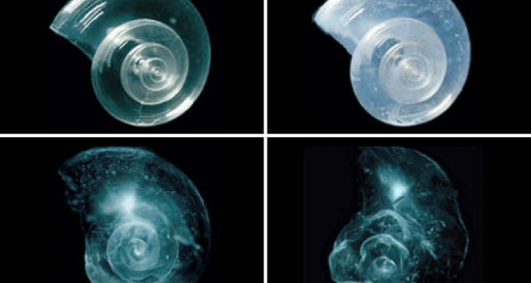](http://ocean.si.edu/sites/default/files/styles/colorbox_full_width/public/photos/PMEL_Feely_dissolving-shells_main_1.jpg?itok=rZKdjvgN)

In a lab experiment, a sea butterfly (pteropod) shell placed in seawater with increased acidity slowly dissolves over 45 days.

**Credit:**Courtesy of David Littschwager/National Geographic Society

Ocean acidification is sometimes called “climate change’s equally evil twin,” and for good reason: it's a significant and harmful consequence of [excess carbon dioxide in the atmosphere](http://ocean.si.edu/climate-change) that we don't see or feel because its effects are happening underwater. At least one-quarter of the carbon dioxide (CO2) released by burning coal, oil and gas doesn't stay in the air, but instead dissolves into the ocean. Since the beginning of the industrial era, the ocean has absorbed some 525 billion tons of CO2 from the atmosphere, presently around 22 million tons per day.

At first, scientists thought that this might be a good thing because it leaves less carbon dioxide in the air to warm the planet. But in the past decade, they’ve realized that this slowed warming has come at the cost of changing the ocean’s chemistry. When carbon dioxide dissolves in seawater, the water becomes more acidic and the ocean’s pH (a measure of how acidic or basic the ocean is) drops. Even though the ocean is immense, enough carbon dioxide can have a major impact. In the past 200 years alone, ocean water has become 30 percent more acidic—faster than any known change in ocean chemistry in the last 50 million years.

Scientists formerly didn’t worry about this process because they always assumed that rivers carried enough dissolved chemicals from rocks to the ocean to keep the ocean’s pH stable. (Scientists call this stabilizing effect “buffering.”) But so much carbon dioxide is dissolving into the ocean so quickly that this natural buffering hasn’t been able to keep up, resulting in relatively rapidly dropping pH in surface waters. As those surface layers gradually mix into deep water, the entire ocean is affected.

Such a relatively quick change in ocean chemistry doesn’t give marine life, which evolved over millions of years in an ocean with a generally stable pH, much time to adapt. In fact, the shells of some animals are [already dissolving in the more acidic seawater](http://ocean.si.edu/ocean-news/searching-ocean-acidification-signal), and that’s just one way that acidification may affect ocean life. Overall, it's expected to have dramatic and mostly negative impacts on ocean ecosystems—although some species (especially those that live in estuaries) are finding ways to adapt to the changing conditions.

However, while the chemistry is predictable, the details of the biological impacts are not. Although scientists have been tracking ocean pH for more than 30 years, biological studies really only started in 2003, when the rapid shift caught their attention and [the term "ocean acidification" was first coined](http://www.nature.com/nature/journal/v425/n6956/full/425365a.html). What we do know is that things are going to look different, and we can't predict in any detail how they will look. Some organisms will survive or even thrive under the more acidic conditions while others will struggle to adapt, and may even go extinct. Beyond lost biodiversity, acidification will affect fisheries and aquaculture, threatening food security for millions of people, as well as tourism and other sea-related economies.

**Acidification Chemistry**

At its core, the issue of ocean acidification is simple chemistry. There are two important things to remember about what happens when carbon dioxide dissolves in seawater. First, the pH of seawater water gets lower as it becomes more acidic. Second, this process binds up carbonate ions and makes them less abundant—ions that corals, oysters, mussels, and many other shelled organisms need to build shells and skeletons.

**A More Acidic Ocean**

Carbon dioxide is naturally in the air: plants need it to grow, and animals exhale it when they breathe. But, thanks to people burning fuels, there is now more carbon dioxide in the atmosphere than anytime in the past 15 million years. Most of this CO2 collects in the atmosphere and, because it absorbs heat from the sun, creates a blanket around the planet, warming its temperature. But some 30 percent of this CO2 dissolves into seawater, where it doesn't remain as floating CO2 molecules. A series of chemical changes break down the CO2 molecules and recombine them with others.

When water (H2O) and CO2 mix, they combine to form carbonic acid (H2CO3). Carbonic acid is weak compared to some of the well-known acids that break down solids, such as hydrochloric acid (the main ingredient in gastric acid, which digests food in your stomach) and sulfuric acid (the main ingredient in car batteries, which can burn your skin with just a drop). The weaker carbonic acid may not act as quickly, but it works the same way as all acids: it releases hydrogen ions (H+), which bond with other molecules in the area.

Seawater that has more hydrogen ions is more acidic by definition, and [it also has a lower pH](http://www.pmel.noaa.gov/co2/story/A+primer+on+pH). In fact, the definitions of acidification terms—acidity, H+, pH —are interlinked: acidity describes how many H+ ions are in a solution; an acid is a substance that releases H+ ions; and pH is the scale used to measure the concentration of H+ ions.

The lower the pH, the more acidic the solution. The pH scale goes from extremely basic at 14 (lye has a pH of 13) to extremely acidic at 1 (lemon juice has a pH of 2), with a pH of 7 being neutral (neither acidic or basic). The ocean itself is not actually acidic in the sense of having a pH less than 7, and it won’t become acidic even with all the CO2 that is dissolving into the ocean. But the changes in the direction of increasing acidity are still dramatic.

So far, ocean pH has dropped from 8.2 to 8.1 since the industrial revolution, and is expected by fall another 0.3 to 0.4 pH units by the end of the century. A drop in pH of 0.1 might not seem like a lot, but the pH scale, like the Richter scale for measuring earthquakes, is logarithmic. For example, pH 4 is ten times more acidic than pH 5 and 100 times (10 times 10) more acidic than pH 6. If we continue to add carbon dioxide at current rates, seawater pH may drop another 120 percent by the end of this century, to 7.8 or 7.7, creating an ocean more acidic than any seen for the past 20 million years or more.

**Why Acidity Matters**

[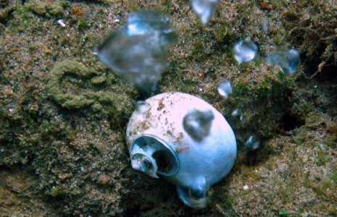](http://ocean.si.edu/sites/default/files/styles/colorbox_full_width/public/photos/Laetitia-Pic-7asmall.jpg?itok=x5u8xLS7)

The acidic waters from the CO2 seeps can dissolve shells and also make it harder for shells to grow in the first place.

**Credit:** Laetitia Plaisance

Many chemical reactions, including those that are essential for life, are sensitive to small changes in pH. In humans, for example, normal blood pH ranges between 7.35 and 7.45. A drop in blood pH of 0.2-0.3 can cause seizures, comas, and even death. Similarly, a small change in the pH of seawater can have harmful effects on marine life, impacting chemical communication, reproduction, and growth.

The building of skeletons in marine creatures is particularly sensitive to acidity. One of the molecules that hydrogen ions bond with is carbonate (CO3-2), a key component of calcium carbonate (CaCO3) shells. To make calcium carbonate, shell-building marine animals such as corals and oysters combine a calcium ion (Ca+2) with carbonate (CO3-2) from surrounding seawater, releasing carbon dioxide and water in the process.

Like calcium ions, hydrogen ions tend to bond with carbonate—but they have a greater attraction to carbonate than calcium. When two hydrogens bond with carbonate, a bicarbonate ion (2HCO3-) is formed. Shell-building organisms can't extract the carbonate ion they need from bicarbonate, preventing them from using that carbonate to grow new shell. In this way, the hydrogen essentially binds up the carbonate ions, making it harder for shelled animals to build their homes. Even if animals are able to build skeletons in more acidic water, they may have to spend more energy to do so, taking away resources from other activities like reproduction. If there are too many hydrogen ions around and not enough molecules for them to bond with, they can even begin breaking existing calcium carbonate molecules apart—dissolving shells that already exist.

This is just one process that extra hydrogen ions—caused by dissolving carbon dioxide—may interfere with in the ocean. Organisms in the water, thus, have to learn to survive as the water around them has an increasing concentration of carbonate-hogging hydrogen ions.